CIS 1513 Course Directions on getting an Oracle Online APEX account
Go to the APEX Website: http://apex.oracle.com/i/index.html (click on REQUEST a WORKSPACE)
It takes you thru a series of steps to create an account, takes about 5 or 10 minutes to get done.
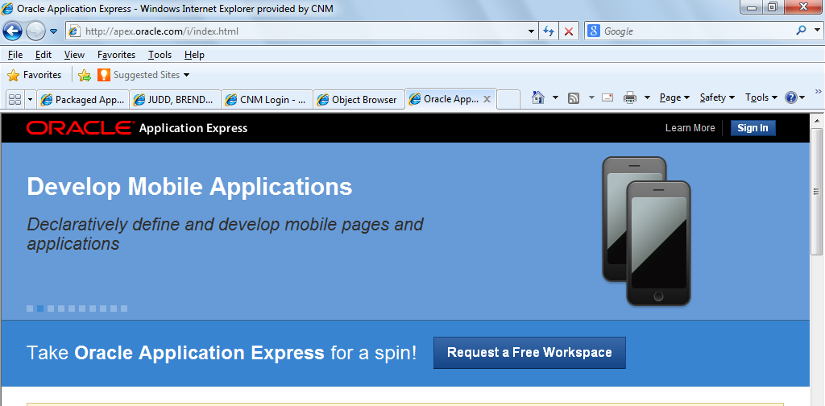
CLICK on GET STARTED
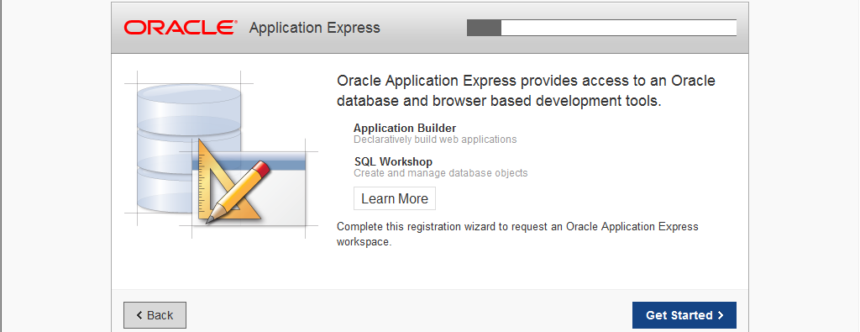
Use your first and last name and use your CNM Email address:
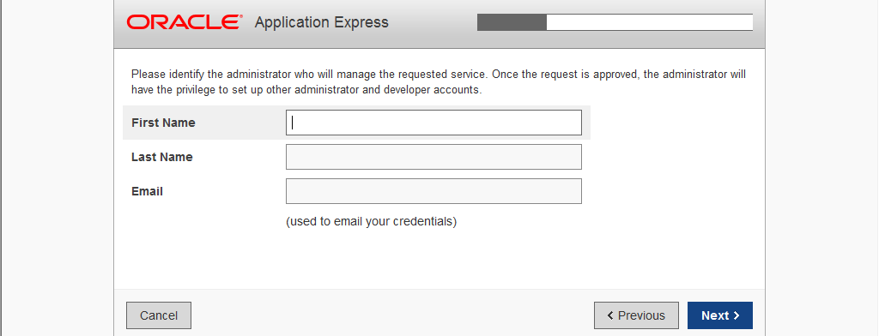

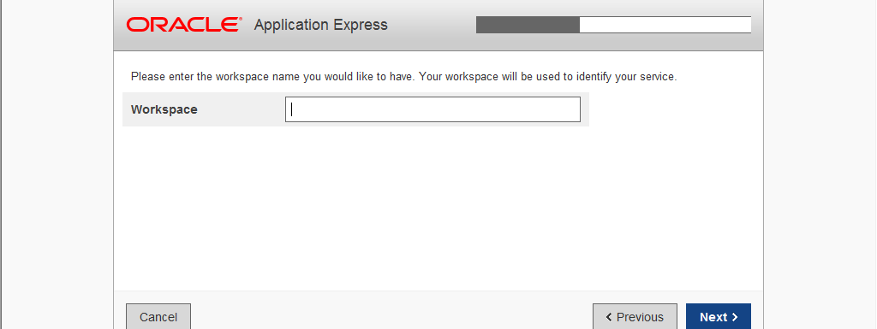
Your last name no spaces

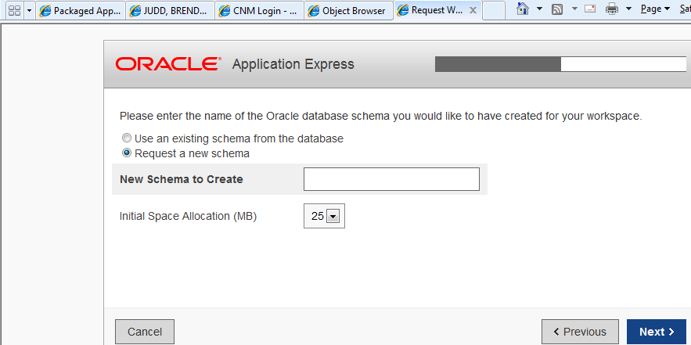
Your last name no spaces
Then you have to fill out this quick survey, here the answers we used:
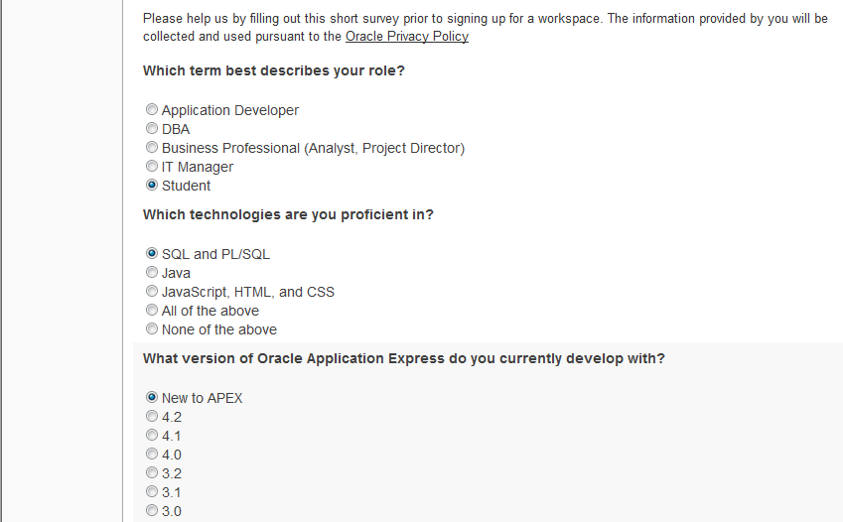
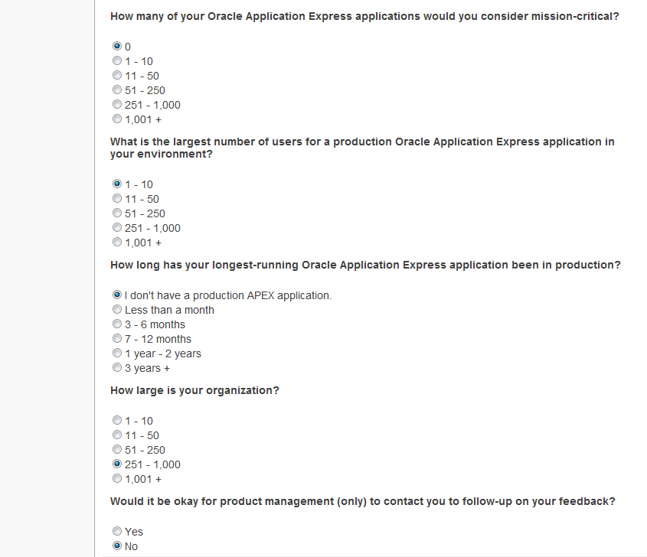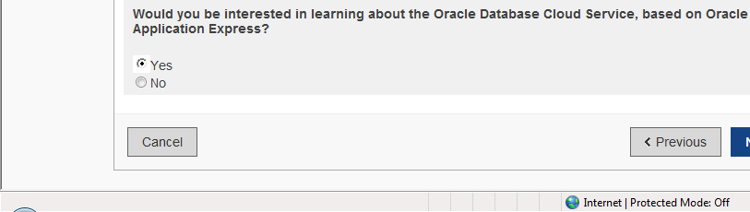
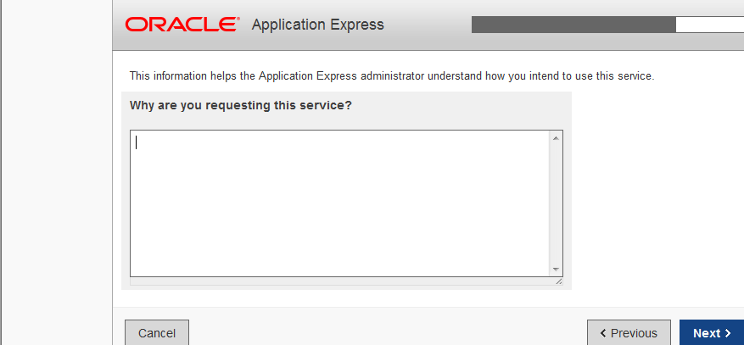
For educational purposes at school
Accept the APEX agreement, by clicking in the box below:
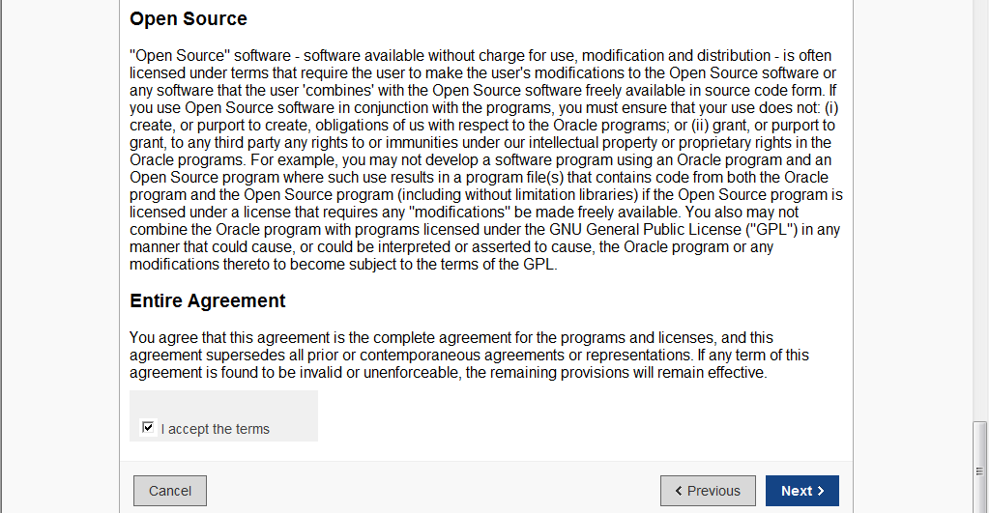
ENTER the Verification Code on your screen not the one below:
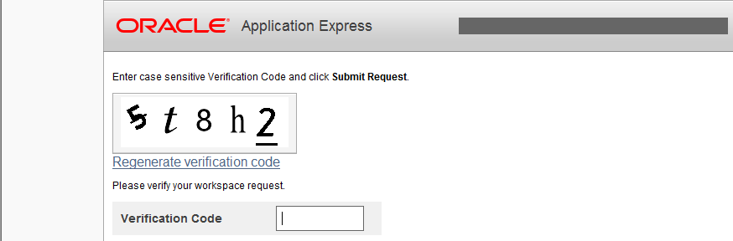
The last screen will show that you have created an account & next you need to wait for the 1st email to confirm
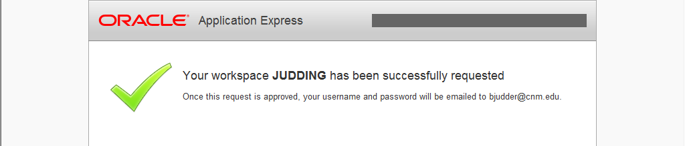

To complete the APEX account process:
Oracle will send you 2 emails

- One to Respond to. This will finalize yr APEX account.
- Another one after you have responded to the 1st email. This one Will have your userid & password
- Then you have to change your password to something you will remember.

Once you get logged on take a look around your new Environment for the next 15 weeks.

